Analytics Doubt and Bug List:

1. Dashboard-MTD hours tail-Percentage value shows 0%-Need to discuss.

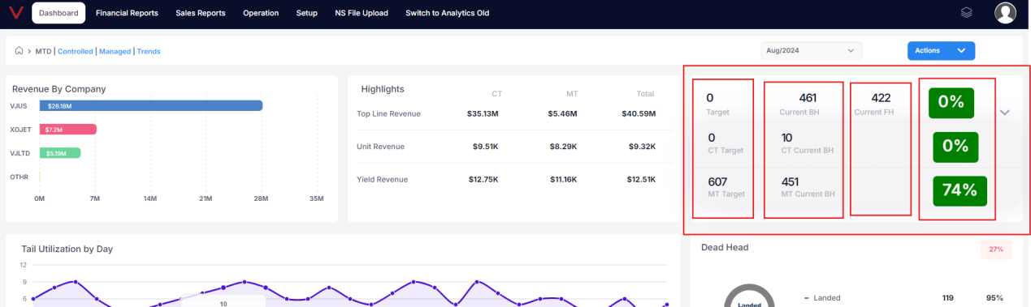

1. Dashboard-MTD hours tail-Click action button-Click export button-Click go to report button and page navigates to Controlled tail page but it need to navigate to MTD Page.

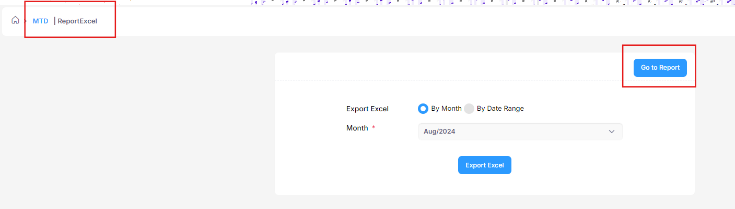

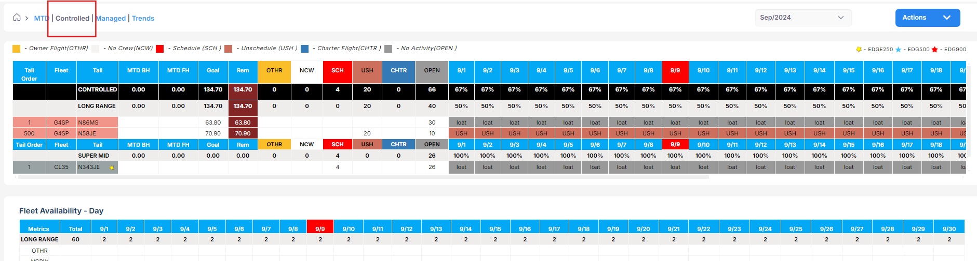

1. Dashboard-MTD hours tail-Click action button-Scheduler-Add/Edit Scheduler-Select controlled or managed tail radio button and enter valid details, then click clear button Schedule time details is not getting cleared and radio button is disabled but it should moves to first option.

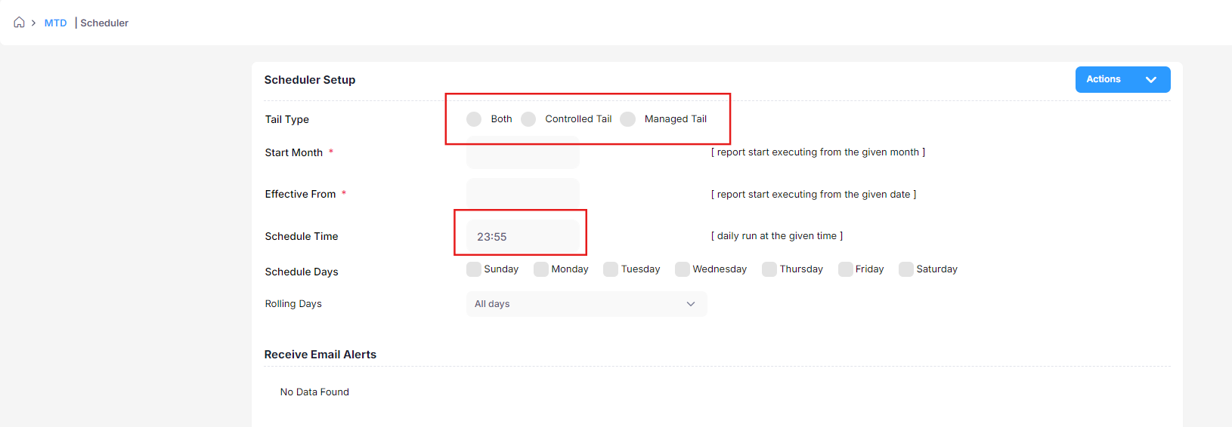

1. Dashboard-MTD hours tail-Click action button-Scheduler-Add/Edit Scheduler-Add external users-without enter any details click save button, alert message is displayed. In alert, “Email ID” need space.

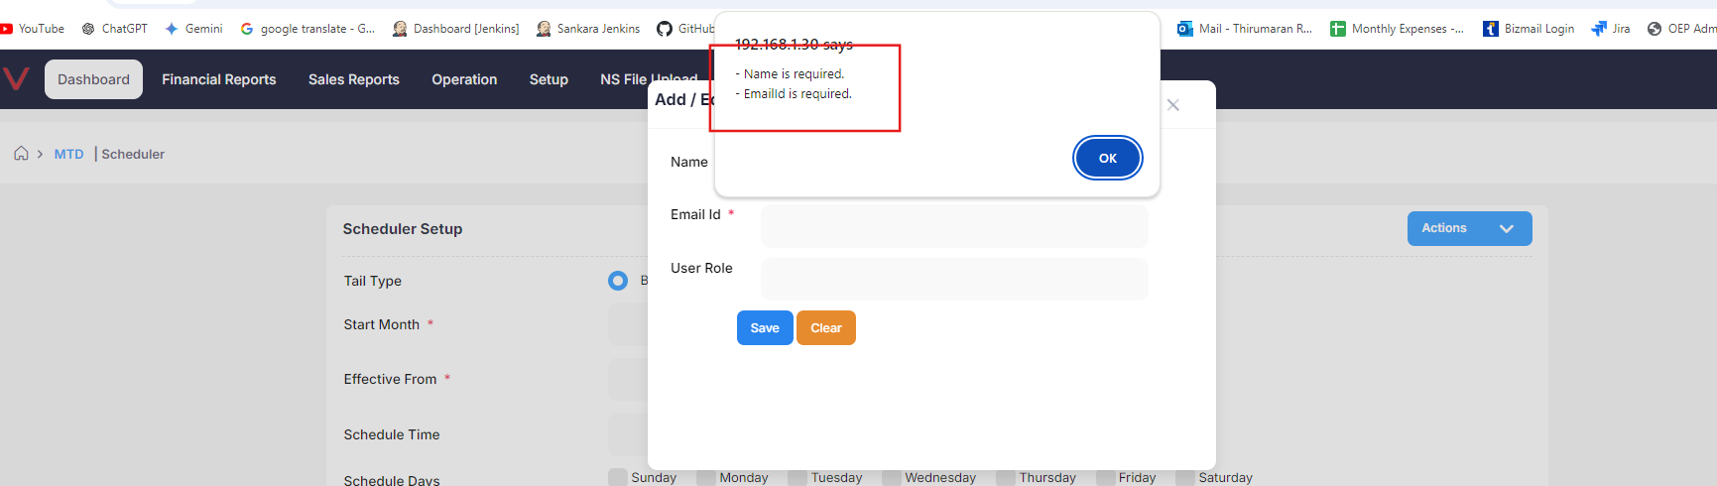

1. Dashboard-MTD hours tail-Click action button-Click show/hide button-Click close button-Then click next option in Day Utilization % by Aircraft in homepage, then show/hide menu pop up is displayed.

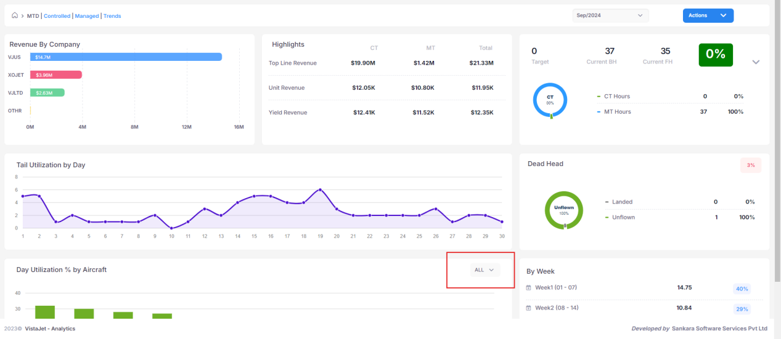

1. Dashboard-MTD hours tail-In By Week menu-when click week button no menu is opened, may be we can disable the click option.

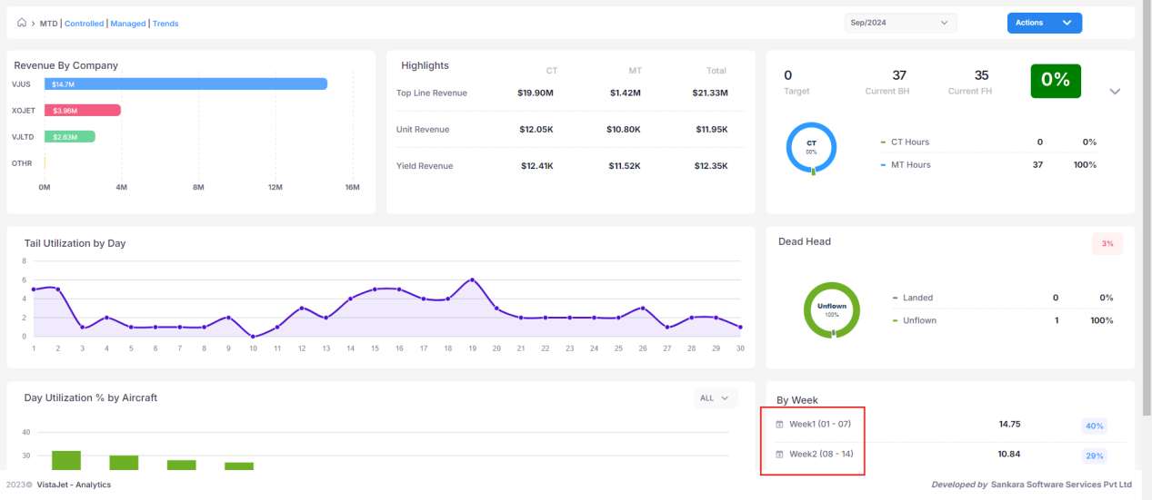

1. Dashboard-Click trends button-Select from month is greater than to month and click run button no alert message is displayed. Need to fix in all page having from and to calendar in analytics portal.

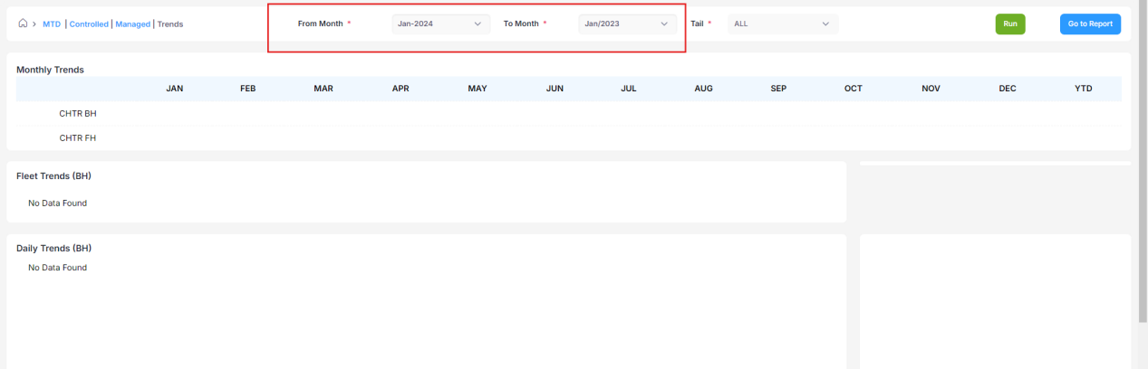

1. Dashboard-Tail availability-select any tail-Select any start and end date- then click delete button page gets crashed.

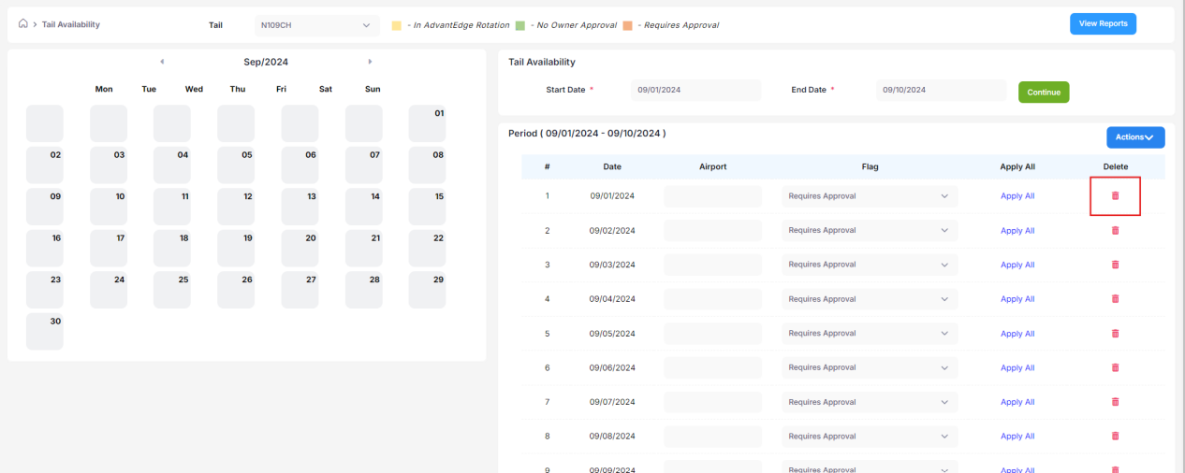

1. Dashboard-When ever I click “who is flying today:” button page display alert message.

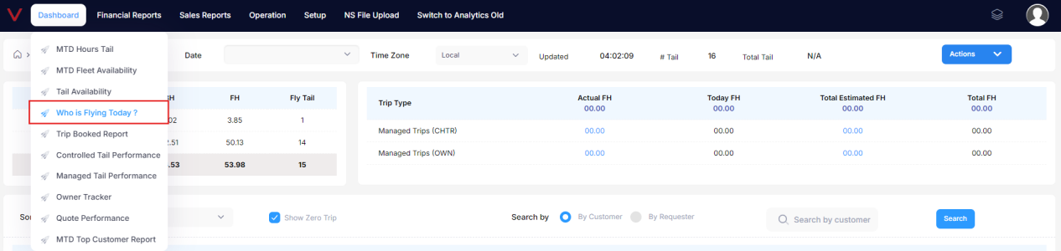

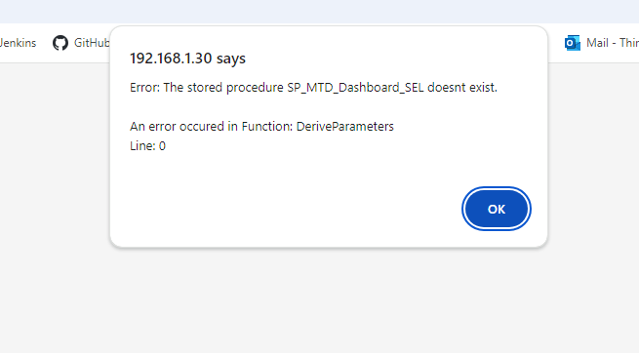

1. Dashboard-Who is flying today-In Trip type details, when click the actual FH or Total EST FH details button, pop up will opened and when try to click close button page gets crashed.

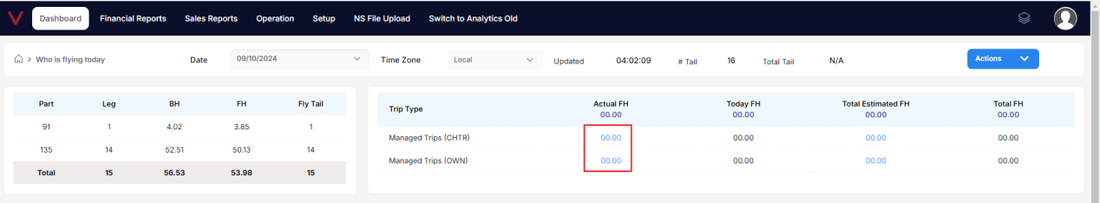

1. Dashboard-Who is flying today-At the end of the page, total alignment is not proper.

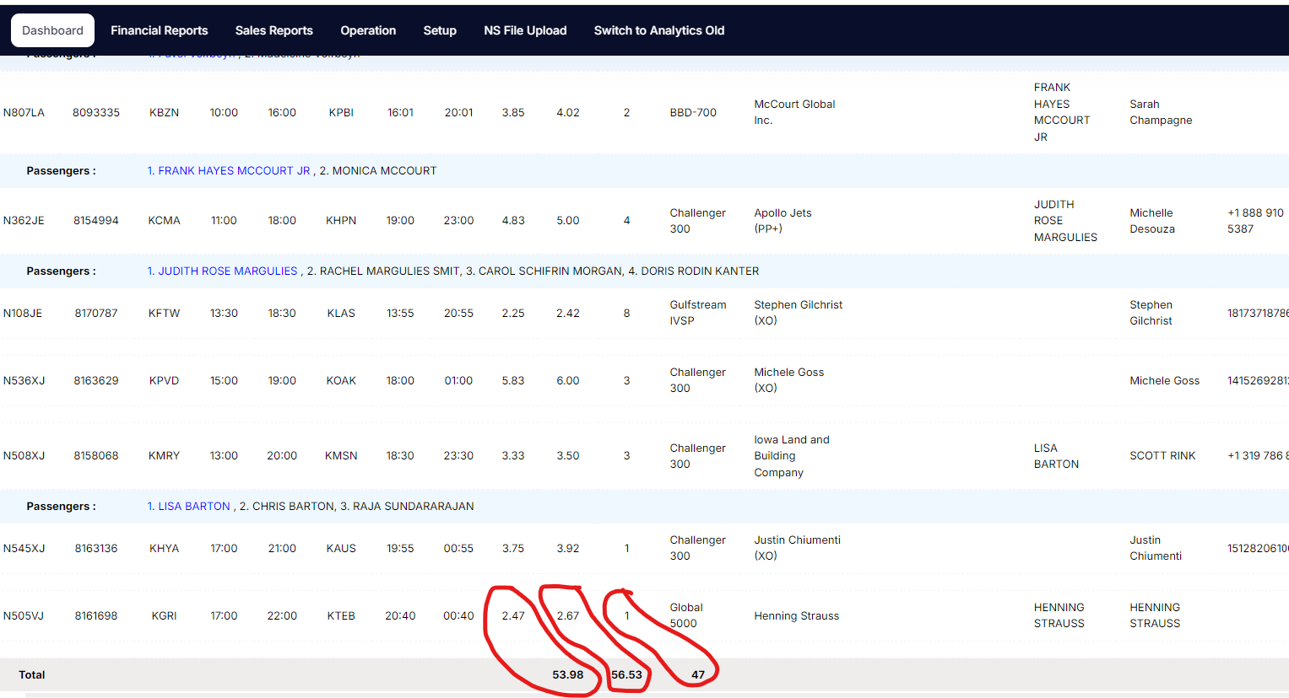

1. Dashboard-Trip booked report-At the end of the page, total value is displayed wrong value. Below green marked value is original value

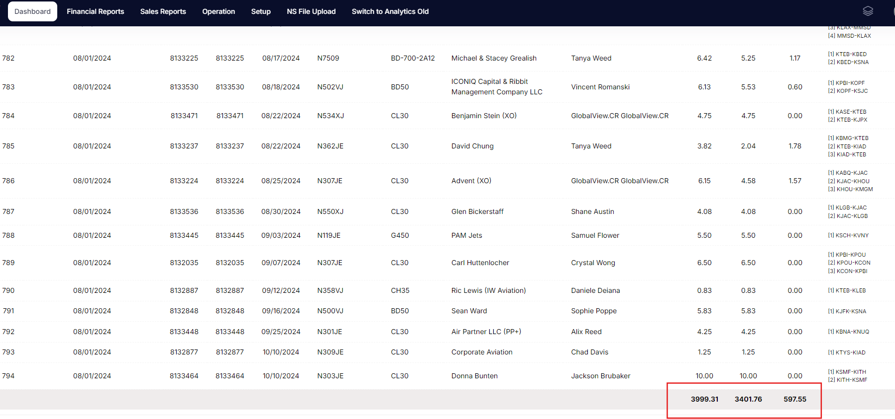

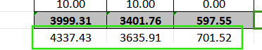

1. Need to check all web table total details once again in every modules and sub-modules.
2. Dashboard-controlled tail performance-operational view-action-goal setup-

* Enter valid detail and click enter button invalid error toast appeared.

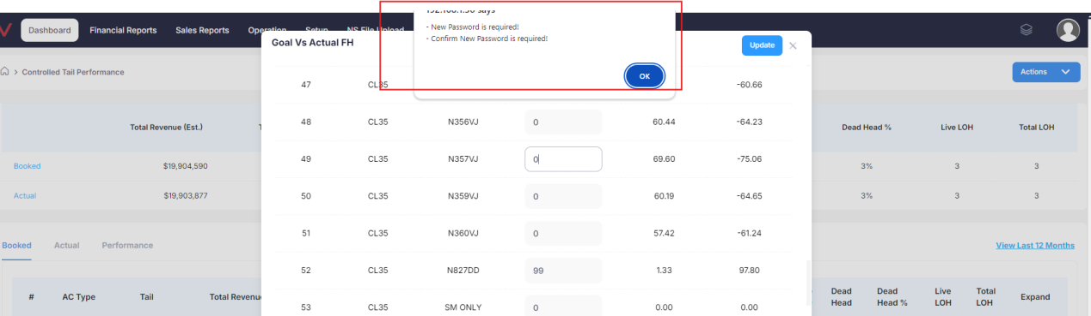

* Enter valid detail and click update button invalid error toast appeared.

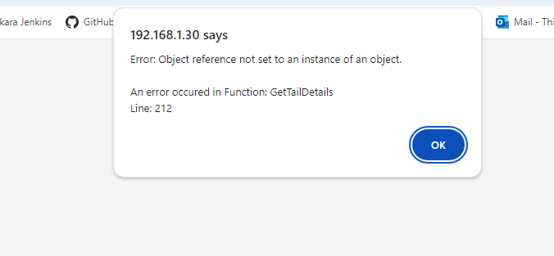

1. Dashboard-controlled tail performance-in right side details, total value is wrong.

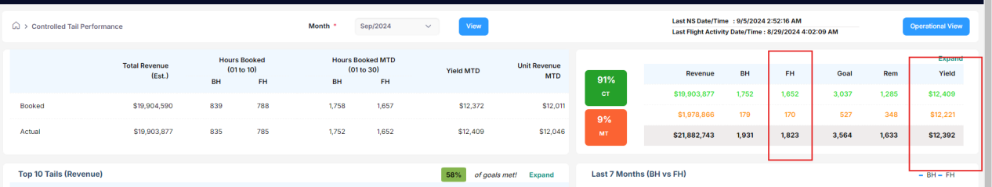

1. Dashboard-when ever try to click the controlled tail performance, managed tail performance button and MTD Top Customer Report alert message is displayed.
2. Dashboard-Owner tracker-Click any view button-Click add new button in fligh log-without enter any values and click save button, page gets crashed.
3. Dashboard-Owner tracker-Click any view button-Click add new button in fligh log-In start and end time alpha charaters able to enter.

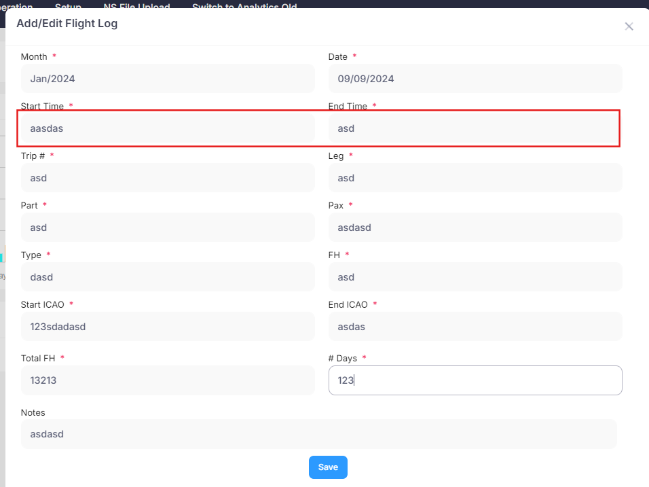

19.Dashboard-Owner tracker-In day requirement details menu, Unselect any checkbox, then again select the checkbox page gets crashed.

20.Dashboard-Owner tracker-In hour requirement details menu, Unselect any checkbox page gets crashed, then again select the checkbox page gets crashed.

1. Dashboard-Option display like Quote Performance and once click it page shows Quote Dashboard.

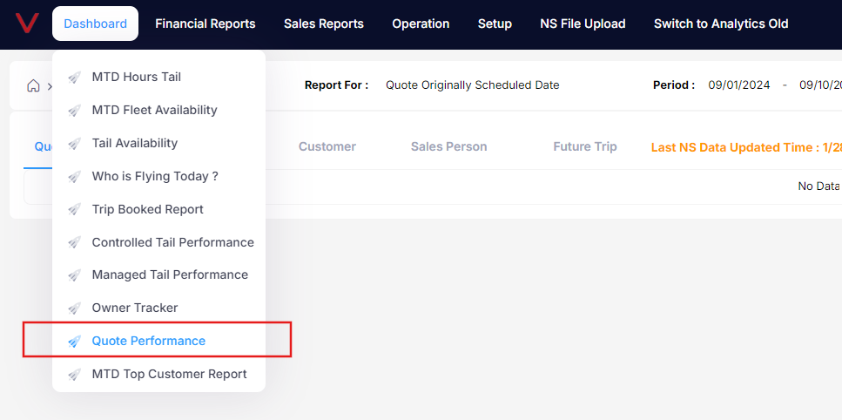

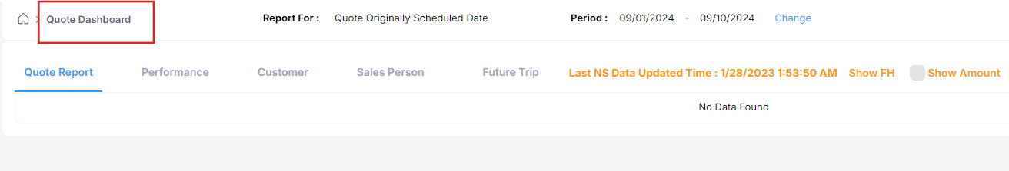

1. Dashboard-Quote performance-Click future trips tab-when click from and to date, two different calendars are opened.
2. Dashboard-Quote performance-Click change button-select valid date and click run button, invalid error toast displayed.

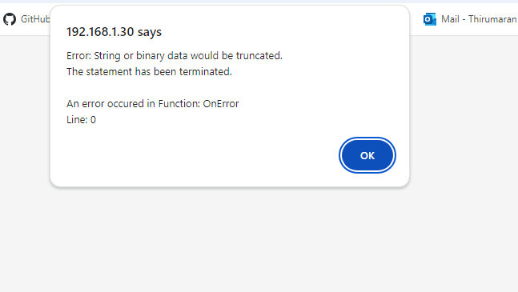

1. Dashboard-Quote Performance:

* Refresh quote vs actual button is not working.
* Click show FH checkbox, alert message is displayed.
* Click show amount checkbox, alert message is displayed.
* Overall, all details inn the module is not properly working. CHeck once again every functionality.

1. Dashboard-Quote Performance-Future trips-Click view button, in that page ascending and descending option is not working after apply(1st and 2nd dropdown are not working).
2. Dashboard-MTD Top customer report-Customer group details displayed wrong alignment.

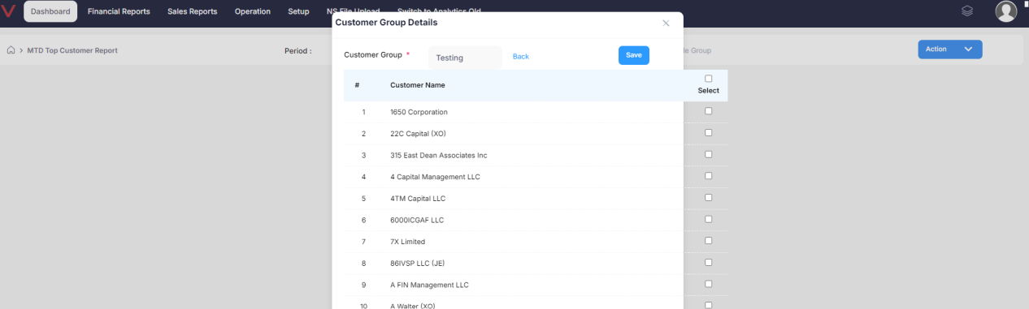

1. Dashboard-MTD Top customer report-Add new-Cannot able to add new customer group, save button is not displayed.

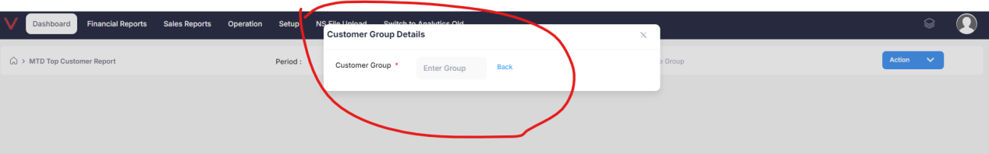

1. Financial reports-Charter Sales Dashboard-In trip type wise details table all total values are wrong.

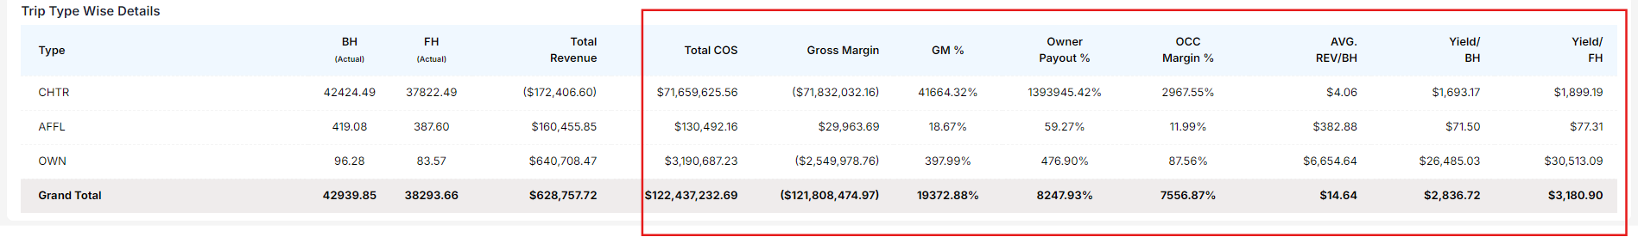

1. Financial reports-P/L by Aircraft-Last three column total value is wrong.

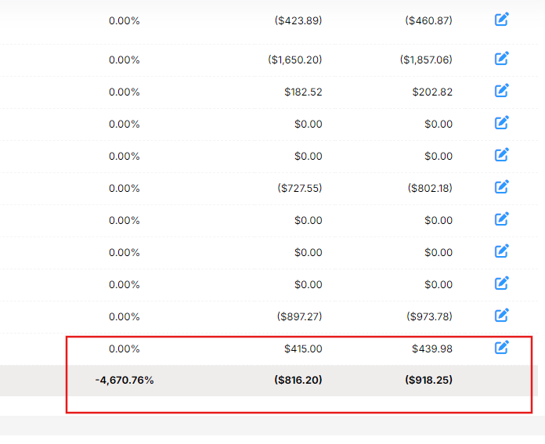

1. Financial reports-P/L by Aircraft-Select rolling option in report by-select all option in aircraft-Click view button, page displayed invalid error toast.

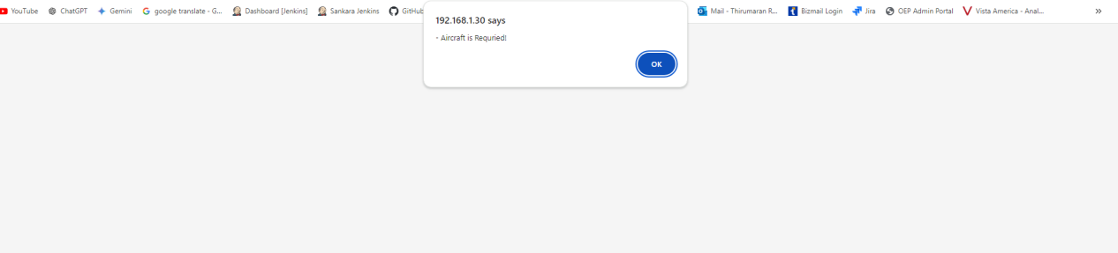

1. Financial reports-P/L by tail-In report type dropdown, by Month option is displayed but “B” must be capital, which means it will look like “By Month”

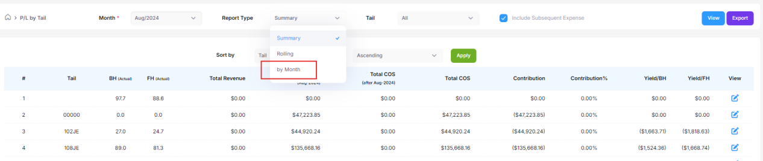

1. Financial reports-State tax appor..-Heading should display full name.



1. Financial reports-Cost accural-select valid month and tail-Click run button- click any trip number, an invalid toast is appeared.

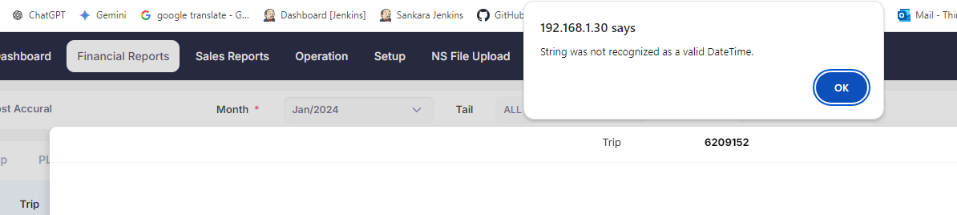

1. Financial reports-Cost accural-Two tabs display same name.

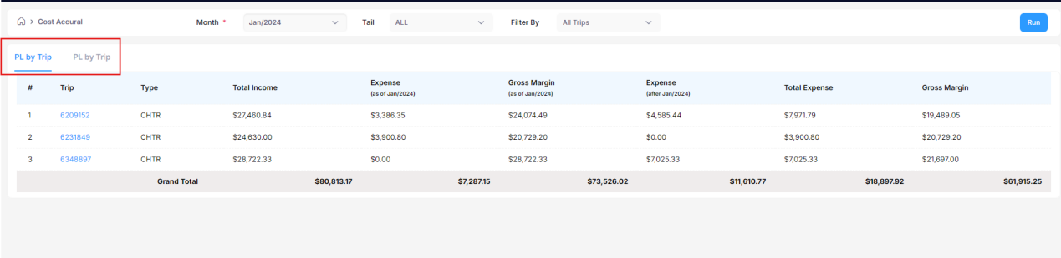

1. Financial reports-Cost accural-1st tab display 3 trip number and 2nd tab display 2 trip number.

1st tab:

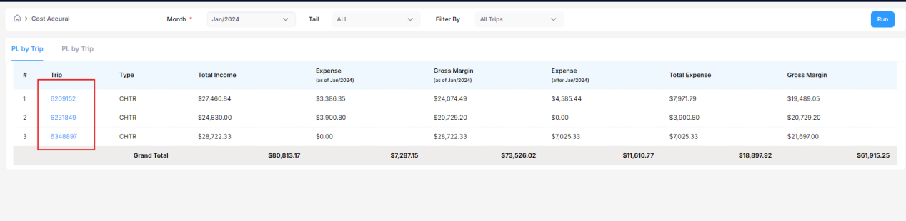

2nd tab:

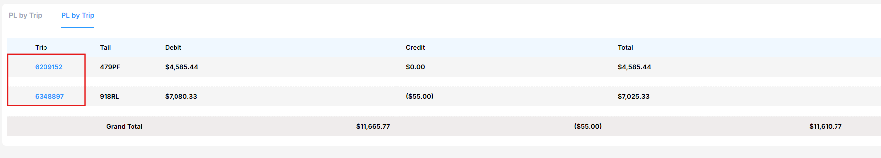

1. Financial reports-Route profit-From and to month calendar is empty.
2. Financial reports-Route profit-Select valid from and to month and click view button-click trip number invalid error toast appeared.

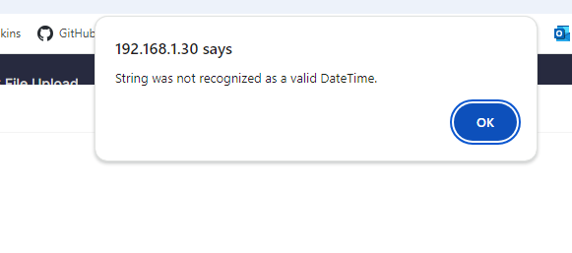

1. Financial reports-Route profit-In last two column, total value is wrong.

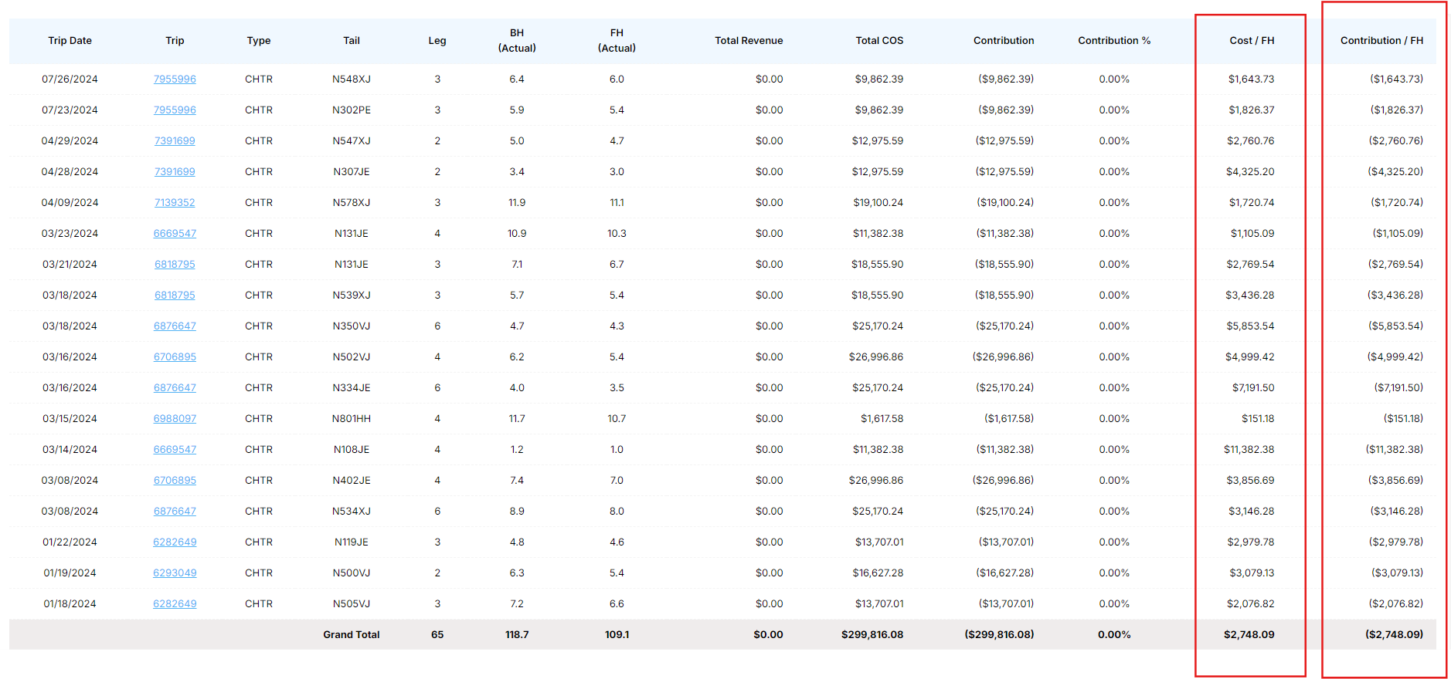

1. Financial Reports-Cost Accural-Spelling is wrong in the word of Cost “Accural”, correct spelling is “Accrual”. Verify once again in online.

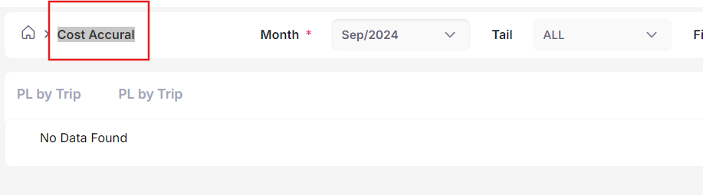

1. Sales Report-Charter Sales Breakdown-In month calendar display both month and date calendars.

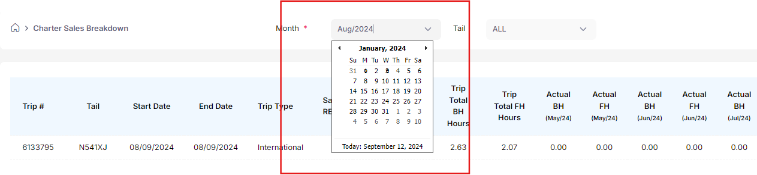

1. Sales Report-Charter Sales Breakdown-Filter option is not working.

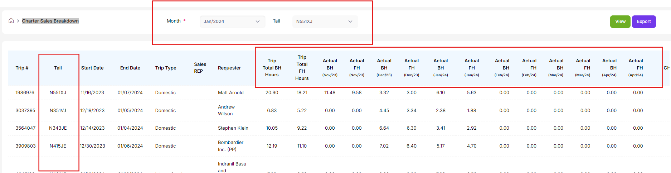

1. Sales Report-Sales By Tail-How to verify below listed details are displayed as per selected month.

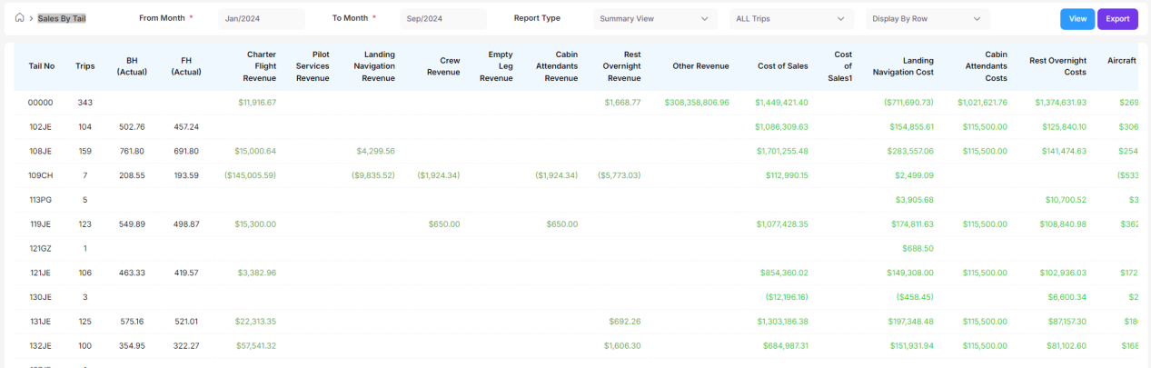

1. Sales Report-Cost Analysis (By Trip)-When enter into the page, page details are in empty, but when have no data to display, then page will show, “No details to show” orelse any other valid message but page should not be in empty status.

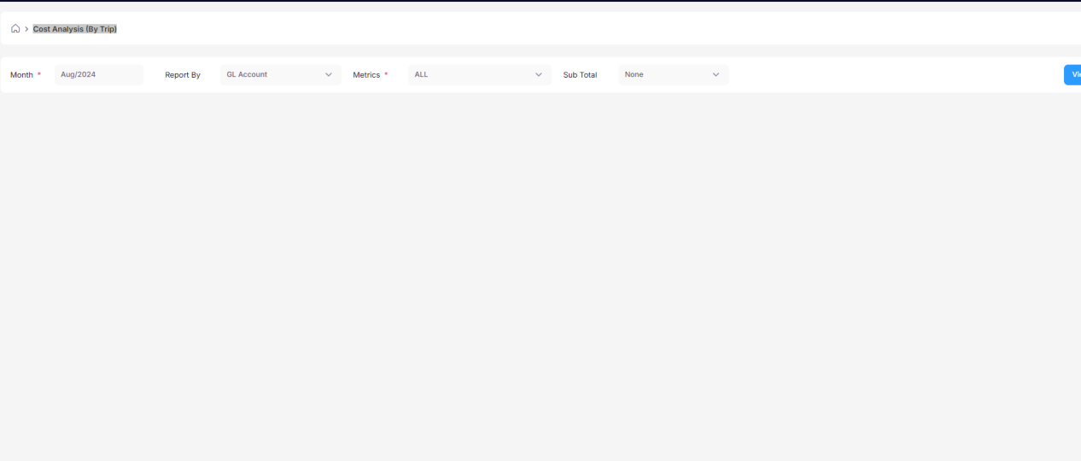

1. Sales Report-Cost Analysis (By Trip)-When select valid month and click view button page displayed invalid error pop up message.(But metrics are in “ALL” option)

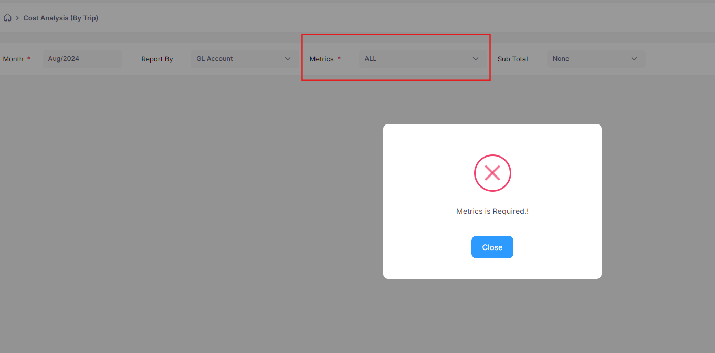

1. Sales Report-Cost Analysis (By Trip)-WHen select valid month, and group option in report by field and select all option, page display error pop up like above screenshot, Then select any other metrics and click view button page display error pop up like below screenshot.

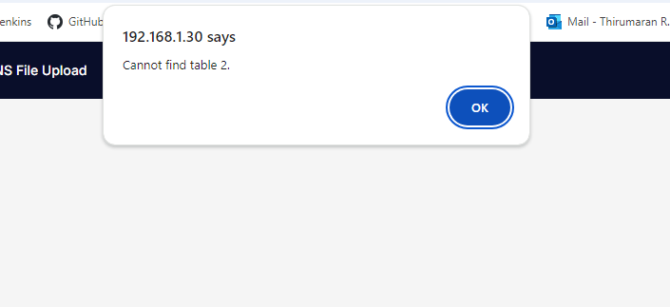

1. Sales Report-Cost Analysis (By Airport)-Refresh button is not working after change the details in all field.



1. Sales Report-Cost Analysis (By Airport)-Click transation tab- Click any price button in the table and click close button in the pop up, page moves to summary page it should be in transaction page only.

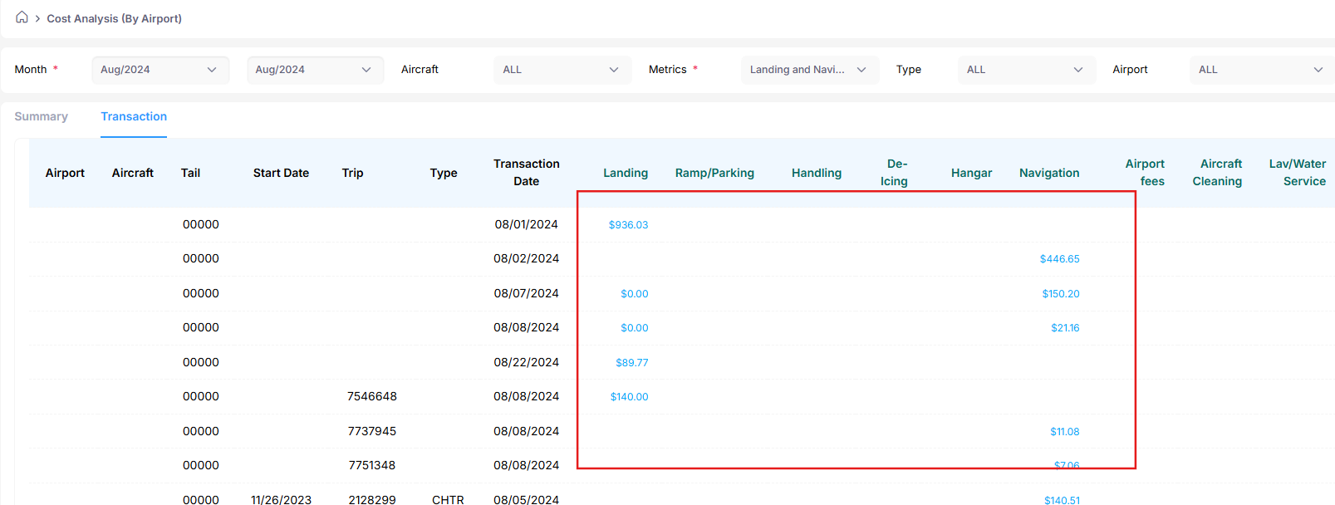

1. Sales Report-Cost Analysis (By Airport)-Total value is wrong in summary tab.

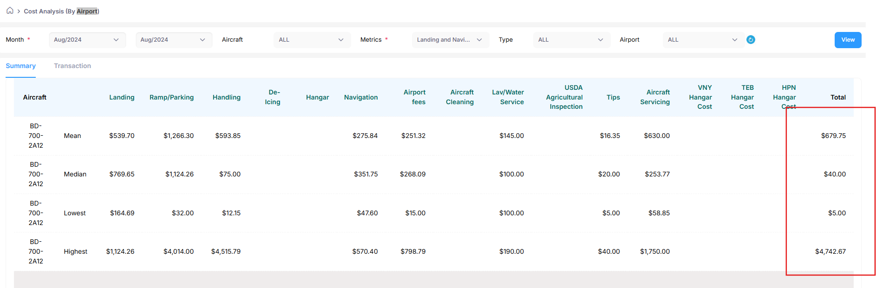

1. Operation-Flight hours-Month caledar display both date and month details.
2. Operation-Empty leg-Click scheduler button-Click edit button-Current status display run button but stauts also running. It need to show stop button.

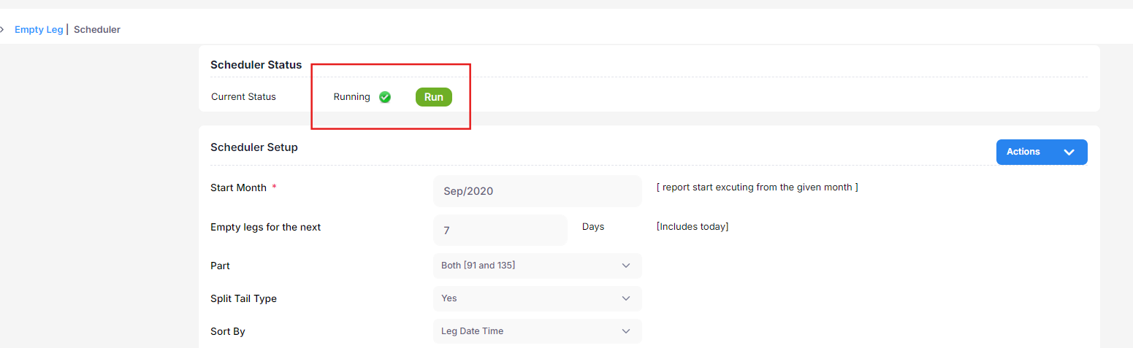

1. Setup-Customer Setup-Add Customer-Add new button is not properly displayed.

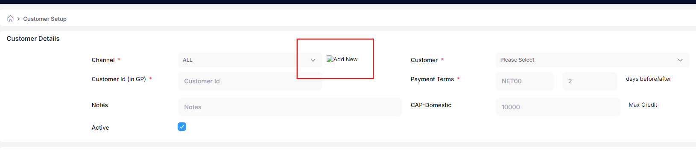

1. Setup-Customer Setup-Add Customer-In Rebates Setup:

* Mandatory symbol is not present in Domestic and international trip tabs.(Without enter and click save button alert message displayed with mandatory message).

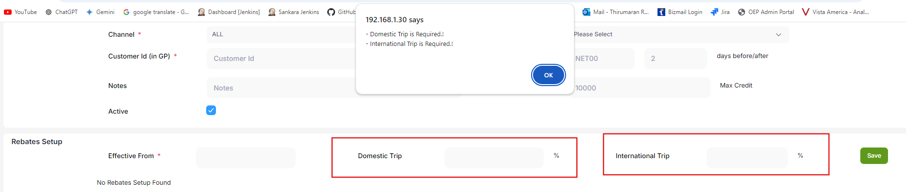

* Effective from option is not displayed in Mandatory message.

1. Setup-Customer Setup-Add Customer-In Retail Mark Up Setup- Effective from option is not displayed in Mandatory message.

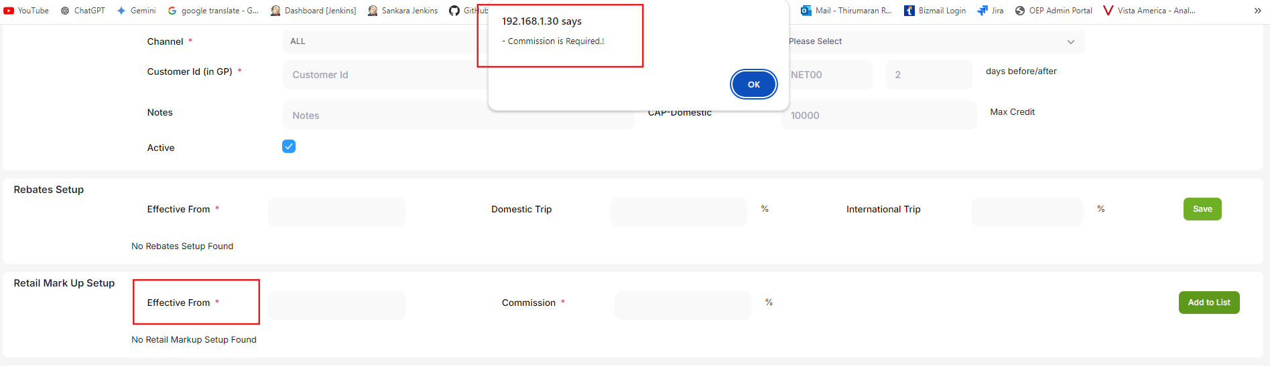

1. Setup-Tail goal setup-Add/Edit-Effective from date alignment is not proper.

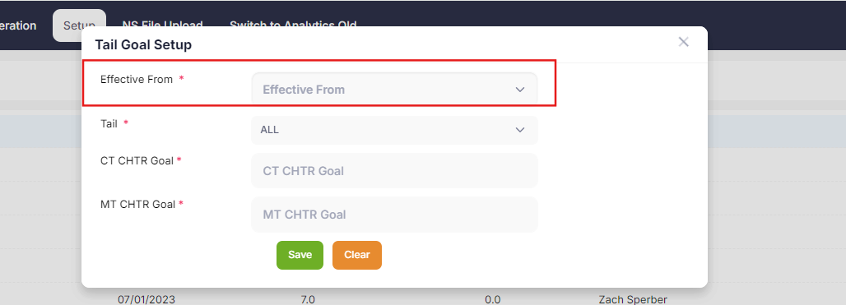

1. Setup-Tail goal setup-Add/Edit-When select a tail, pop up is automatically closed.